DIGITAL SIGNAL PROCESSING PROJECT
INTRODUCTION
Real-world signals acquired from sensors and electronic devices are affected by noise, whose nature depends on the acquired signal and the acquisition methods, and which may be caused, for example, by thermal variations, electromagnetic interference, or electrical mains noise. The information content of the signal is therefore altered, since part of its components consists of noise. To solve this problem, filtering is fundamental: it consists of analyzing the signal in the frequency domain in order to isolate the frequencies of interest in the acquired signal, removing those caused by noise. The result is an improved signal-to-noise ratio (SNR). In this context, digital filters are much more useful and versatile than analog filters, since they provide greater versatility, flexibility, and lower sensitivity to environmental parameters, and they will therefore be the focus of this work.

OBJECTIVES
The objective of this work is the design and analysis of two digital filters to be applied to a noisy signal acquired by means of a microcontroller, followed by the analysis of the filtered signal and the calculation of quality metrics such as SNR and mean squared error (MSE). In particular, the signal is obtained by sampling, using an ESP32 microcontroller, the analog signal read at the output of an NTC thermistor (whose resistance varies inversely with ambient temperature). To reduce the noise component present in the acquired signal, two different digital filtering approaches are compared:
- an FIR (finite impulse response) filter
- an IIR (infinite impulse response) filter
It is important to specify that the filters being designed are linear time-invariant (LTI) systems. Consequently, the principle of superposition can be applied and the system properties can be considered unchanged throughout the entire analysis.

THEORETICAL BACKGROUND
This project makes use of a number of mathematical and engineering concepts that are worth reviewing so that the reader has all the tools necessary to understand the text.
Starting from the mathematical concepts, it is necessary to recall the concept of the Fourier transform. For a signal x(t) belonging to the class $L^{2}(R)$, the Fourier transform is defined as:
$$X\left(iω\right)=\int_{-∞}^{+∞}{x(t)e^{-iωt}dt}$$
where i is the imaginary unit and $ω=2πf$, angular frequency, and f is frequency.
The transformation allows the function x(t) to be analyzed in the frequency domain, thus studying its spectrum. This is particularly advantageous because noise is usually located at frequencies different from those containing the information content of the acquired signal.
For digital signals x(n) consisting of N samples, the transform is defined as:
$$X\left(k\right)= \sum_{i=0}^{N-1}{x(n)e^{-i\frac{2π}{N}k}}$$
The discrete transform can be computed digitally very quickly using the Cooley-Tukey algorithm, or FFT (Fast Fourier Transform), whose low complexity O(nlog(n)) allows fast implementation even on machines with limited computational capabilities, such as microcontrollers.
Since filters are systems, it is useful to analyze them in the s and z domains; therefore, the concept of the one-sided Laplace transform is introduced. For a regular signal x(t) of at most exponential order, its Laplace transform is defined as:
$$X\left(s\right)= \int_{0}^{+∞}{x(t)e^{-st}dt}$$
The Laplace transform has several properties that allow differential equations to be transformed into algebraic equations, thus facilitating system analysis, since systems are governed precisely by systems of differential equations.
For a discrete, regular signal x(n) of at most exponential order, the Z-transform is instead defined as:
$$X\left(z\right)= \sum_{n=0}^{+∞}{x(n)z^{-n}}$$
Its function is analogous to that of the Laplace transform, but for discrete-time systems, such as digital filters.
Since system analysis will constitute a section of the project, it is useful to introduce the concept of a system transfer function. The transfer function of a linear time-invariant (LTI) system describes the relationship between input and output in the transform domain and is defined as the ratio between the transform of the output and the transform of the input, under zero initial conditions. For continuous-time systems, the reference domain is the Laplace domain, and therefore the transfer function is defined as:
$$G\left(s\right)= \frac{Y(s)}{X(s)}$$
where Y(s) and X(s) are respectively the Laplace transforms of the system output signal y(t) and the input signal x(t). The system is said to be asymptotically stable if the poles of the transfer function have negative real parts. Asymptotic stability is a necessary property for the design of a suitable filter.
For discrete-time systems, on the other hand, the reference domain is the z domain and, analogously to the continuous-time case:
$$G\left(z\right)= \frac{Y(z)}{X(z)}$$
where Y(z) and X(z) are respectively the Z-transforms of the system output signal y(n) and the input signal x(n). In this case, asymptotic stability is achieved if the poles have magnitude less than 1 and are therefore inside the unit circle.

The concept of sampling is now introduced. Sampling converts a continuous-time (analog) signal into a discrete sequence of numerical samples (digital signal). It consists of measuring and recording the amplitude of the analog signal x(t) at regular, fixed time intervals, called the sampling period $T_{δ}$. The Nyquist theorem provides a condition under which the sampled signal exactly represents the analog signal, without any loss of information. This occurs if the following conditions are satisfied:
- The signal to be sampled must be band-limited, a condition always satisfied by real signals
- The sampling period must be uniform
- The sampling frequency $f_{δ}$ must be at least twice the bandwidth of the signal being sampled $f_{s}$, that is:
$$f_{δ}≥{2f}_{s}$$
If the Nyquist conditions are not satisfied, aliasing occurs, whereby frequencies above the Nyquist frequency ($\frac{f_{δ}}{2}$) overlap with lower frequencies. As will be seen, this detail will reappear in the spectral analysis of the filtered signal.
The quality metrics considered are now introduced:
- SNR: defined as the ratio between the power of the useful component of the signal (the information content) and the power of the noise contained in the signal. SNR is often expressed in dB
$$SNR= \frac{Ps}{Pn}$$
Recalling that the power of a generic analog signal x(t) is defined as:
$$Ps= \lim_{T→∞}{\frac{1}{T}\int_{-\frac{T}{2}}^{\frac{T}{2}}{|x(t)|^{2}dt}}$$
while for discrete signals x(n):
$$\lim_{N→∞}{\frac{1}{2N+1}\sum_{n=-N}^{N}{|x(n)|^{2}}}$$
- Mean Squared Error (MSE): a statistical metric that measures the mean of the squared differences between the actual values and the values estimated or predicted by a model. In our context, it represents the mean error between the original signal and the filtered signal and therefore the average power of the noise. Given the expected signal $x_{a}$, the MSE is calculated as:
$$MSE= \frac{1}{N}\sum_{i=1}^{N}{{(x}_{i}-x_{a,i})^{2}}$$

REQUIRED COMPONENTS
The following hardware and software components were used to carry out the project:
- ESP32 microcontroller, used for sampling the analog signal, and the Arduino IDE development environment for programming
- Thermistor
- Resistor of at least 10 kΩ to properly configure a voltage divider with the thermistor
- Python with the numpy, scipy, pandas, control, and matplotlib modules for data analysis and graph plotting
SYSTEM DESIGN
Since this is a DSP project, the designed filters are discrete-time systems to be applied to a digital signal. The adopted approach is post-processing: the microcontroller is used exclusively for data acquisition, while the filters are applied in post-processing to the entire acquired data set.
At this point, the fundamental parameters for system design are defined.
Thermistors produce slowly varying signals because, by nature, temperature changes slowly. Consequently, the signal of an ideal thermistor (without noise) contains low-frequency components, at most equal to 3 Hz. The noise present in the signal is therefore located at frequencies above 3 Hz. The filters to be designed will consequently be low-pass filters, i.e. systems that leave low frequencies unchanged and strongly attenuate higher frequencies. The Nyquist theorem is therefore applied, according to which the minimum sampling frequency is $f_{δ}=6$ Hz. The sampling frequency selected for the project is $f_{δ}=32$ Hz, corresponding to a sampling period $T_{δ}=$0.03125s. Oversampling (sampling at a frequency higher than the Nyquist frequency) is essential both to improve precision and because it allows the Tustin transformation to be applied, whose function will be explained later.
The cutoff frequency $f_{t}$ is now set to 3 Hz. The cutoff frequency is the frequency at which the power of the signal at a filter's output is reduced to half its maximum value, corresponding to an amplitude attenuation of -3 dB. Above the cutoff frequency, the transition band is entered, where frequencies are attenuated by more than half. Since the width of the transition band will be required when designing the FIR filter, it is set to a known value of $∆f=5$ Hz, not excessive with respect to the system dynamics.
As the IIR filter, it was decided to implement a simple exponential moving average (EWM) filter, a discrete-time system whose difference equation is:
$$y\left(n\right)= αx\left(n\right)+\left(1-α\right)y\left(n-1\right), α ∈ ]0,1]$$
Having defined the frequencies that characterize the system, it is possible to derive the parameter $α$ that guarantees them using the following formula:
$$α=1-e^{-2π\frac{f_{t}}{f_{δ}}}=0.445$$
The formula is an approximation that is valid in this case because $f_{δ}≫ f_{t}$.
Transforming the difference equation and calculating the ratio $\frac{Y(z)}{X(z)}$ leads to the system transfer function:
$$G\left(z\right)= \frac{αz}{z+α-1}$$
As specified, the system is also asymptotically stable because there is only one pole at $\left(1-α\right)=0.555$. At this point, it is essential to study the Bode plots of the system. To do so, the Tustin transformation is applied in order to study the continuous-time equivalent of the discrete-time system. The Tustin transformation can be applied for $f_{δ}≥{8f}_{t}$, a condition satisfied by the selected parameters. Substituting:
$$z= \frac{1+\frac{T_{δ}}{2}s}{1-\frac{T_{δ}}{2}s}$$
In
$$G\left(z\right)= \frac{αz}{z+α-1}$$
The result is:
$$G\left(s\right)= \frac{1+\frac{T_{δ}}{2}s}{1+\frac{T_{δ}(2-α)}{2α}s}= \frac{1+0.015625s}{1+0.054598s}$$
It should be noted that, obviously, the transformation to continuous time does not alter the stability properties.
The Bode plots of G(s) can easily be obtained using a Python script that uses the .frequency_response(G,omega) method from the control library. The resulting plot is:
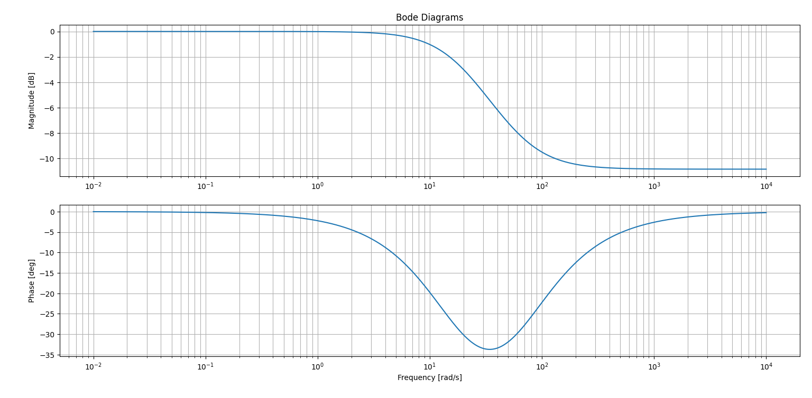
Note: the reported Bode plot represents the system response up to angular frequency $ω=10000 rad/s$ for completeness; however, it should be remembered that, since the signal was sampled at 32 Hz, the actual system response stops at $ω=2πf_{δ}≈201 rad/s$.

The DC gain is consistently 0 dB: as expected, the low-frequency components of the input signal remain unchanged, while those at frequencies above 3 Hz fall within the transition band and the stopband. It can in fact be seen from the graph that at angular frequency $ω>18.8 rad/s$ ($f=\frac{2π}{ω}= 3Hz)$, the input signal components are attenuated by at least 3 dB, as expected for the selected parameters.
The frequency response nevertheless highlights the main problem of IIR filters: although they are less computationally expensive, they introduce nonlinear phase. A known result that can be derived from the frequency response is that EWM filters have a phase represented by the function:
$$φ\left(ω\right)=-arctan⁡(\frac{\left(1-α\right)\sin\left(T_{δ}ω\right)}{1-\left(1-α\right)\cos\left(T_{δ}ω\right)})$$
The phase delay introduced is therefore nonlinear and is expressed in number of samples. It is calculated as:
$$∆φ\left(ω\right)= -\frac{φ\left(ω\right)}{ω}= \frac{1}{ω}arctan⁡(\frac{\left(1-α\right)\sin\left(T_{δ}ω\right)}{1-\left(1-α\right)\cos\left(T_{δ}ω\right)})$$
The nonlinear phase delay complicates the treatment and analysis of the filter, especially for applications operating at high frequencies. At low frequencies, an approximation can be used to simplify the calculation. In fact, for $ω→0, sinω ≈ ω , cosω ≈1$, the phase delay becomes constant and equal to:
$$∆φ= \frac{1-α}{α}$$
Since the filters were chosen to be implemented in post-processing, the .ewm() method of the pandas Python library can be used to perform the filtering operation.
For the FIR filter, the design choice was a windowed filter with linear phase. This type of filter operates in the frequency domain by applying an ideal filter to the transform of the signal to be filtered, represented in the time domain by a discrete function $Asinc\left(ωn\right)= \frac{Asin(πωn)}{πωn}$. However, since the ideal filter is non-causal and has infinite duration, it cannot be directly implemented on a computer. To make it realizable, the impulse response must be truncated to a finite number N of points (called taps). A sharp truncation is equivalent to multiplying sinc(n) by a rectangular window: since multiplication in time corresponds to convolution in the frequency domain, this truncation causes the Gibbs phenomenon, i.e. oscillations (ripple) near the system cutoff frequency. To mitigate this problem, the rectangular window is replaced with a smoother window function w(n). In this project, a Hann window was chosen, which drastically reduces Gibbs oscillations by going to zero at the edges, at the cost of a slightly wider transition band between the passband and stopband. It is a versatile solution suitable for general-purpose applications, whose mathematical expression is:
$$w\left(n\right)=0.5-0.5cos⁡(\frac{2πn}{N-1})$$
Although these operations are theoretically and mathematically complex, the software implementation of this type of filter is straightforward. In fact, the firwin(taps, cutoff, window, sampling_frequency) function from the scipy Python library can be used to return the coefficient vector representing the impulse response of the system obtained by specifying the function parameters. To find the required number of taps, the following formula can be used:
$$N= \frac{cf_{δ}}{∆f}$$
where c is a parameter that depends on the window; for the Hann window, c = 3.1. It is also often useful to set N to the nearest larger odd integer resulting from the calculation, as this helps ensure that the system frequency response passes exactly through -3 dB. Therefore, the result is N = 21. At this point, the scipy.signal lfilter_zi function can be used to set the system initial conditions, and the lfilter function, also from scipy.signal, can be used to perform the filtering with the obtained coefficients. As in the case of the IIR filter, it is essential to analyze the Bode plots. In this case, it is not necessary to go through the continuous-time transfer function: instead, scipy's freqz function can be used to plot the system Bode plots starting from the impulse-response coefficients. The result is the following:
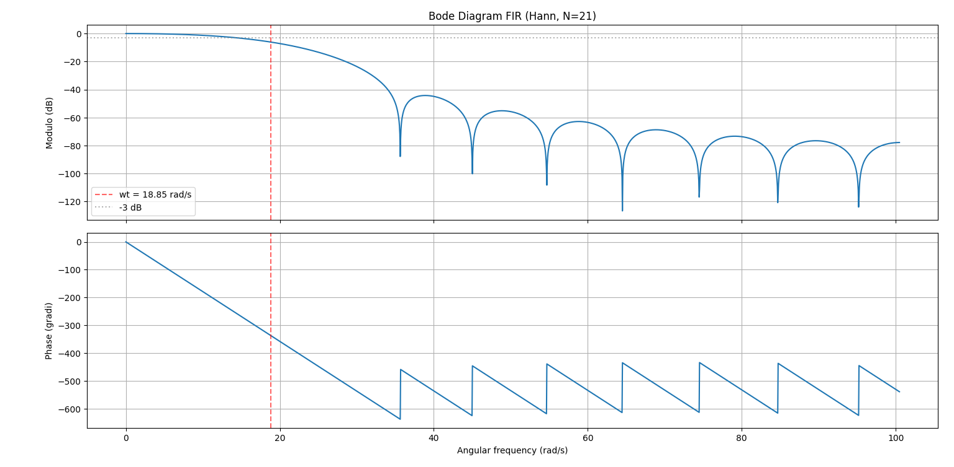
In this case as well, the resulting filter is a low-pass filter with zero DC gain and, as desired, the transition-band width is 5 Hz and at f = 3 Hz the magnitude is reduced by more than 3 dB. It is interesting to note the presence of jumps in both the magnitude and phase plots: these are caused by zeros in the impulse responses and produce the characteristic lobe-shaped behavior of Hann-windowed FIR filters. In the magnitude plot, the secondary lobes show increasing attenuation, indicating that the higher the frequency, the greater the attenuation, as desired. The phase plot, on the other hand, has a linear behavior, with discontinuities of $±180°$ visible at each zero of the magnitude response. The main advantage of this type of filter over IIR filters is precisely that the phase follows a linear trend; consequently, the introduced phase delay is constant and therefore much easier to handle than in the previous system. In particular, the delay is:
$$∆φ= \frac{N-1}{2f_{δ}}$$
SOFTWARE IMPLEMENTATION
Some implementation and practical choices have already been discussed in the previous section, but it is worth focusing on some potentially ambiguous sections of code. First of all, the project required the use of several scripts, some for analysis and others for filtering. A useful first script was serial.py, used to read the data sent by ESP32 to the serial monitor and quickly create a .csv file, which was then required for filtering and data analysis.
Regarding the filtering scripts, attention should be paid to some sections.
For EWM filtering, for example, it was particularly useful to use the .ewm method of pandas, applied to the set of values read from the dataset. This implementation is the most concise and readable, as well as particularly convenient because it allows us to remain within the pandas environment, without using external libraries and without manually iterating through the dataset.
df = pd.read_csv(data) #opening the csv file

#creates a new column called EMA signal which contains the filtered signal
df["ema_signal"] = df[signal_column].ewm(alpha = alpha, adjust = False).mean()

#ewm is in pandas environment, so i don't need to use .values method

df.to_csv(data, index = False)

The FIR filtering code is slightly more complex. It would have been possible to apply the filtering entirely in post-processing, completely cancelling the delay introduced by the filter through software methods; however, the adopted approach is more natural and closer to what the microcontroller would do in firmware.
The lfilter_zi function scales the initial conditions of the filter, adapting them to the first input of the system. It takes the filter coefficients, i.e. k, and the denominator of the transfer function as inputs; for an FIR filter, the latter is always equal to 1. The initial-condition vector zi is then passed to the lfilter function, which applies the filtering to the input data. This operation is essential to avoid anomalous transients and, in general, to obtain a more consistent response. It should also be noted that the lfilter function returns the final state zf, which is particularly useful in block-based systems, but is not relevant in this case.
k = firwin(N, cutoff = ft, fs = fs, pass_zero= True, window = 'hann')

#at this point, i decide to apply the filter sample by sample, in order to visualize
#the delay caused by the filtering operation

zi = lfilter_zi(k, [1.0]) * x[0] #adjusting filter's starting state
y, zf = lfilter(k , [1.0], x, zi = zi)

#defining a new column in the csv file called fit_signal
df["fir_signal"] = y
df.to_csv(data, index = False)

It should also be noted that in both filtering scripts, a column was added to the CSV file containing the acquired data, making it possible to maintain a single file containing the raw signal, the EWM-filtered signal, and the FIR-filtered signal.
The scripts used to plot the Bode diagrams of the designed systems were also useful; these have already been discussed above and do not present any elements requiring particular attention.
It is important, however, to focus on the code used to analyze the obtained signals, since it is more complex and potentially error-prone than the others. The code consists of three sections: transformation of the signals into the frequency domain, MSE calculation, and SNR calculation.
Starting from the transformation phase, it consists of several preliminary steps useful for cleaning the signal:
- Subtracting the mean to the numeric signal
raw_x = raw_x - np.mean(raw_x)
ema_x = ema_x - np.mean(ema_x)
fir_x = fir_x - np.mean(fir_x)

- Removing casual trends on the acquired signal
raw_x = detrend(raw_x)
ema_x = detrend(ema_x)
fir_x = detrend(fir_x)

- Apply a window to reduce spectral leakage, which is the phenomenon whereby the energy of a given frequency spreads to neighboring frequencies, making nonexistent frequencies appear. The window chosen here as well was the Hann window, due to its versatility. In this case, the implementation choice was to use a single window for all signals; this was possible and correct because the EMA and FIR signals were obtained from the raw signal and therefore have the same length. In general, it would be more correct to use a different window for each signal being transformed.
nr = len(raw_x)

#applying hann window in order to reduce spectral leakage

win = get_window('hann', nr)

raw_wx = raw_x * win
ema_wx = ema_x * win
fir_wx = fir_x * win

- Transform the signals into the frequency domain

raw_y = rfft(raw_wx)
raw_f = rfftfreq(nr, d = 1/fs)

raw_amp = np.abs(raw_y) / (np.sum(win) / 2) #normalizing amplitude not considering negative frequency
raw_amp[0] = raw_amp[0] / 2 #used in order not to double DC component (mean value)

#ema signal:

ne = len(ema_wx)
ema_y = rfft(ema_wx)
ema_f = rfftfreq(ne, d = 1/fs)

ema_amp = np.abs(ema_y) / (np.sum(win) / 2) #normalizing amplitude not considering negative frequency
ema_amp[0] = ema_amp[0] / 2 #used in order not to double DC component (mean value)

#fir signal

nf = len(fir_wx)
fir_y = rfft(fir_wx)
fir_f = rfftfreq(nf, d = 1/fs)

fir_amp = np.abs(fir_y) / (np.sum(win) / 2) #normalizing amplitude not considering negative frequency
fir_amp[0] = fir_amp[0] / 2 #used in order not to double DC component (mean value)

The MSE calculation simply uses the formula reported in the previous sections.
Regarding SNR, however, a clarification is necessary. Since the definition of noise is not rigorous, it can be arbitrarily fixed depending on the context of the work. In this case, the chosen definition greatly simplifies the calculations and treatment without being approximate: any signal component at a frequency higher than 3 Hz is defined as noise. With this consideration, the SNR calculation code is quite straightforward:
def compute_snr(freq, amplitude, cutoff):
#snr is defined as a ratio of powers
#power is defined as the square of amplitude

power = amplitude ** 2

#signal_mask and noise_mask are boolean array
#they are used in order to sum correctly the components

signal_mask = freq <= cutoff
noise_mask = freq > cutoff

signal_power = np.sum(power[signal_mask]) #sum of every signal component
noise_power = np.sum(power[noise_mask]) #sum of every noise component

snr_linear = signal_power / noise_power
snr_db = 10 * np.log10(snr_linear) #multiplying by 10 cause we're working with power

return snr_db

Finally, the ESP32 firmware is analyzed. The code is actually very simple because it performs a sampling operation. To ensure that sampling occurs accurately and to avoid potential blocking caused by repeated delay() or millis() calls, the interrupt mechanism and the Ticker library were used, the latter allows a ticker object enabled for interrupts to be defined. In this respect, an ESP32 was preferred over an Arduino Uno: the ESP32 generally provides better interrupt management and more interrupt-capable pins. The code therefore remains simple and easy to read.
#include <Ticker.h>

#define ADC_PIN 34

Ticker ticker; //ticker: executes a function with a precise frequency
double ts = 0.03125;

volatile bool flag = false; //volatile cause modified in ISR
volatile int counter = 0;

void ISR_function(){ //defining the ISR function
flag = true;
counter++;
}

void setup() {
delay(10000);
Serial.begin(115200);
pinMode(ADC_PIN, INPUT);
analogSetAttenuation(ADC_11db);

ticker.attach(ts, ISR_function); //initializing ticker

Serial.println("time,x");

}

void loop() {
if(flag){
double value = analogRead(ADC_PIN);
Serial.print(counter * ts, 5);
Serial.print(",");
Serial.println(value);
flag = false;
}
}

RESULTS ANALYSIS
The results obtained with the two filters are now compared. We begin with the analysis in the time domain:
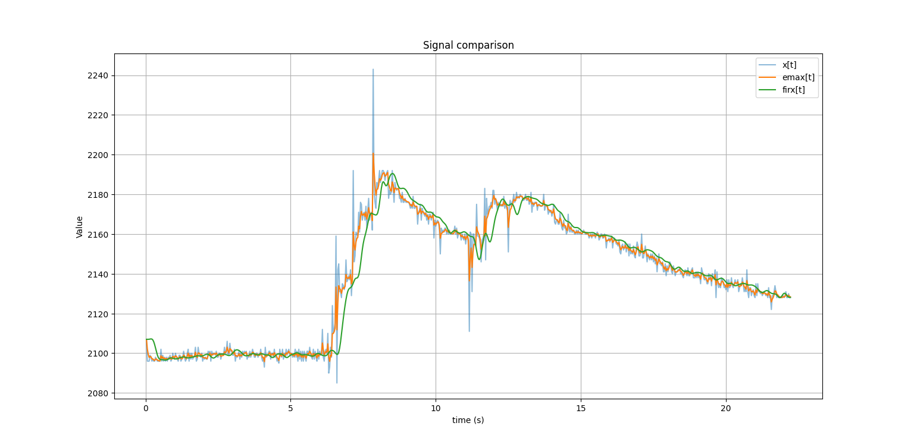
The raw signal x[t] and the signal filtered with EWM, emax[t], follow a very similar trend, but it is evident that emax[t] is much cleaner than x[t], with lighter and more regular spikes. The EWM is also faster than the FIR in responding to irregular values, but it maintains a rigid trend. Moreover, as expected, the delay introduced by the EWM is practically zero, since the signal is low-frequency and the approximation presented above is therefore valid. In contrast, in the time domain the constant phase delay introduced by the FIR is evident: it is therefore slower, but at the same time it guarantees a much cleaner and more regular response, better able to handle spikes and thus providing superior noise-attenuation performance. It is worth noting, however, the initial settling of firx[t], typical of signals filtered with FIR systems.
Moving instead to the Fourier-domain analysis, it can first be observed that most signal components, both raw and filtered, are located at very low frequencies (< 1 Hz), confirming that the signal produced by a thermistor varies slowly and is concentrated at low frequencies. Most components are in fact contained in the 0–4 Hz band. Up to 4 Hz, the signals are practically superimposed, with firx(f) maintaining slightly better attenuation performance. Above 4 Hz, the filtered signal firx(f) is practically zero, meaning that the FIR filter has almost completely eliminated all signal components at frequencies greater than 4 Hz while preserving the informative content. The EWM filter, on the other hand, continues to follow the raw signal, while still strongly attenuating it and therefore reducing the noise.
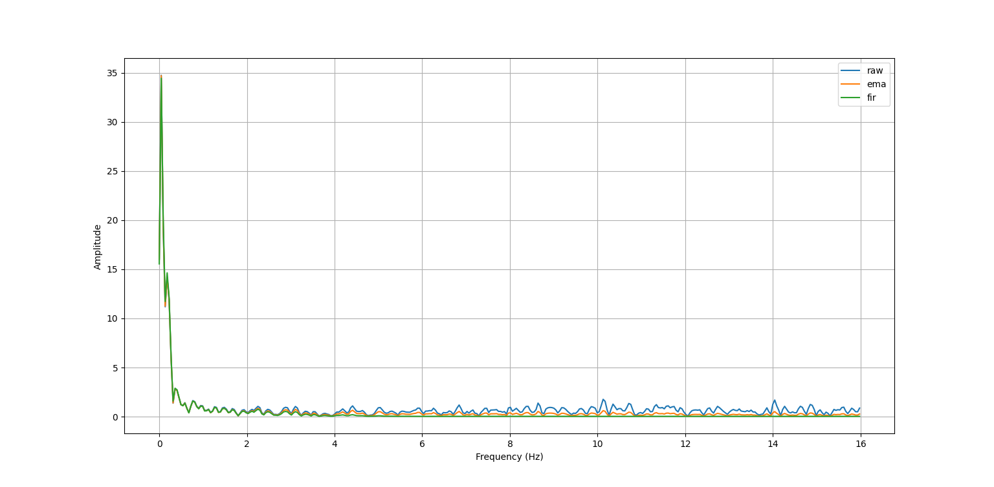
The small spike at 14 Hz should also be noted: it is almost certainly electrical mains noise. Since the mains frequency is 50 Hz and the sampling frequency is 32 Hz, the aliasing frequency can be calculated using the folding formula:
$$f_{alias }=|f-kf_{δ}|$$
with k chosen so that $f_{alias }∈[0, \frac{f_{δ}}{2}]$, where $\frac{f_{δ}}{2}$ is simply the maximum representable frequency for the $f_{δ}$ selected according to the Nyquist theorem. Substituting f = 50 Hz and k = 2 gives precisely $f_{alias }=14Hz$.
Moving now to the analysis of the calculated quantitative metrics, the following results were obtained:
SIGNAL | MSE | SNR
x[t] | // | 12.935436463873536
emax[t] | 12.967640767911018 | 21.298204813441895
firx[t] | 55.312498290071765 | 34.08591552000726

They confirm what could already be inferred from the graphical analysis alone. The EWM filter improved the SNR by approximately 75%, obtaining a fairly good mean squared error: this means that the filter attenuated a large part of the noise component without excessively modifying the signal, as demonstrated by the not particularly high MSE value. The FIR performance, however, requires more careful analysis. In fact, the filter almost tripled the signal-to-noise ratio, while nevertheless obtaining a very high MSE. This apparently anomalous MSE value is actually explained by two factors:
- The FIR attenuation is very strong for frequencies above 4 Hz. Where the raw signal retained fairly significant components attributable to thermal noise, or noisy components folded into lower frequencies due to aliasing, the filtered signal is practically zero. This strong attenuation is confirmed by an excellent SNR value.
- The phase delay introduced by the FIR is quite evident, as seen in the time domain: this delay increases the MSE because, by definition, the MSE compares the raw and filtered signals at the same sample. Consequently, if the filtered signal is shifted with respect to the raw signal, the equation calculates the squared error between the current raw-signal value and the value that the filtered signal had $∆φ$ samples earlier, with a phase delay of $∆φ$.
FINAL CONSIDERATIONS
The EWM filter certainly provides good performance, both in terms of SNR and MSE, and is simpler and lighter to implement because it is less computationally expensive and can easily be executed even on a microcontroller. In this case, it is particularly suitable because, when working with low-frequency signals, the phase approximation is valid and therefore its nonlinearity is practically imperceptible. It should nevertheless be noted that in a different context, for example when working with higher-frequency signals, EWM performance could vary significantly precisely because of the nonlinear phase, which is more difficult to handle.
On the other hand, the FIR filter achieves significantly better noise-rejection performance, as is evident by comparing its SNR with that of the raw signal and that of the EWM-filtered signal. In addition, the FIR filter attenuates the input signal much more strongly, which in a context such as this is very positive, but in other contexts could be disadvantageous. It also has a higher computational cost and, in this case, introduces a delay that cannot be neglected, complicating the system dynamics.
Based on the considerations above, the EWM filter is considered more suitable for applications involving slowly varying signals where very strong noise rejection is not required, or simply where computational resources are very limited, for example in real-time signal analysis, as occurs in control systems. The FIR filter is instead preferable when the goal is to eliminate as much noise as possible, at the cost of much greater computational complexity. It should also be remembered that, in post-processing, the phase delay introduced by the FIR can be eliminated using software methods such as scipy's filtfilt function.
The choice between the two systems therefore strongly depends on the application context and the nature of the problem.

